**Try to discharge your body static electricity before touching with circuit board and chips.**

**Software Installation Guide and General Issues**

1. Download Software from Blackboard section 383-002



2. Unzip files, and install MAPLAB IDE

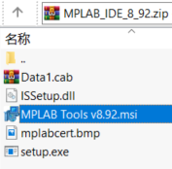

3. Install Complier ‘ mplabc30_v3_30c_windows



Chose Lit Compiler when it asks you the installation type.

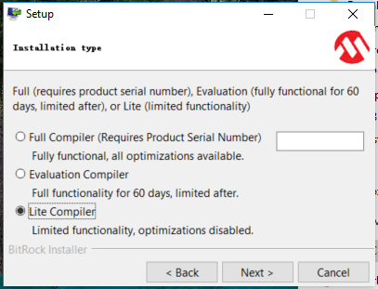

4. All example files are in ‘pic_code_examples_maplab8’. We need to use examples in ‘chap3’. Unzip the **whole** file, and copy the **whole** file to somewhere, we will use it in the lab.



5. To run a simulation chose Debugger->Select Tool-> 4 MPLAB SIM

To write the program into a chip, chose 7

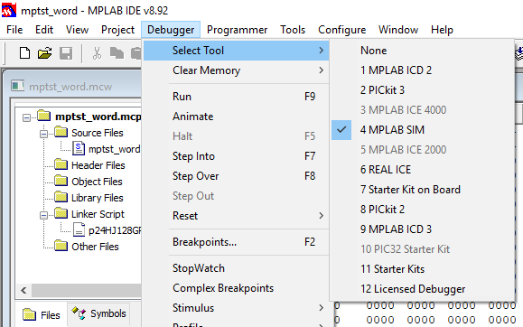

6. (You can jump this step) For the reason of old software version, win10 got some issue in sometime. Right click software icon, choose Compatibility->Override High DPI scaling behavior

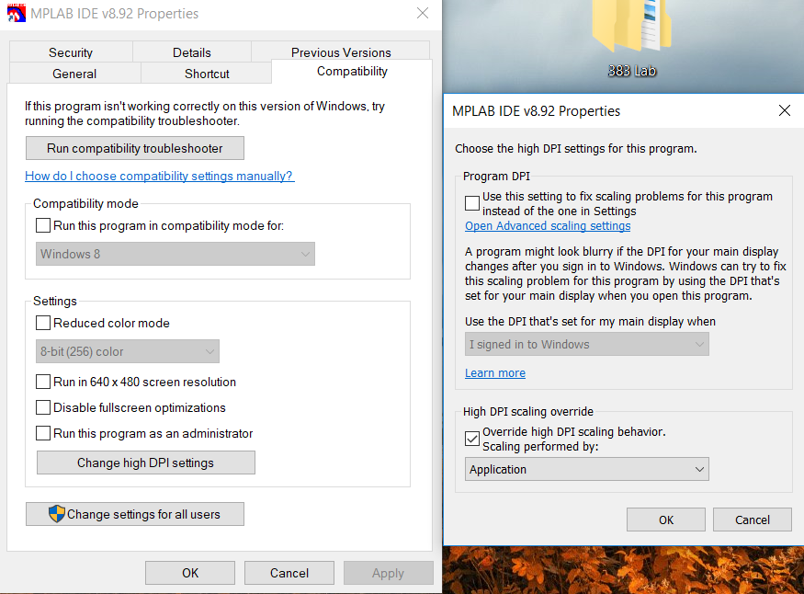

7. You may also miss Assembly Complier file.

Chose Project->Select language Toolsuite…

Then, chose the correct path for the lib files as shown in the following figure.

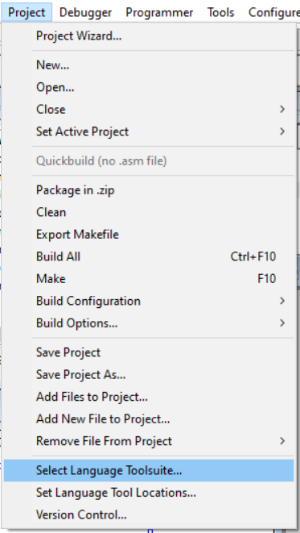

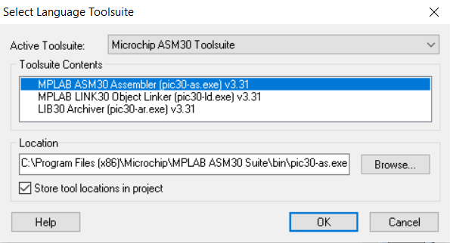

**Task 1.**

**7. Sometimes, you may miss the PIC24 lib file.**

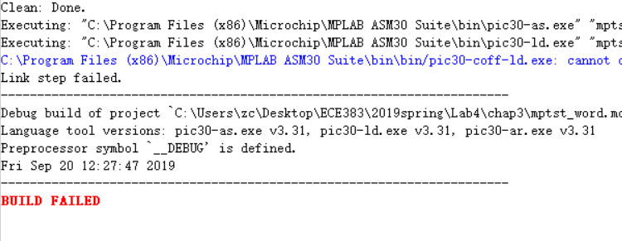

Click View->Project

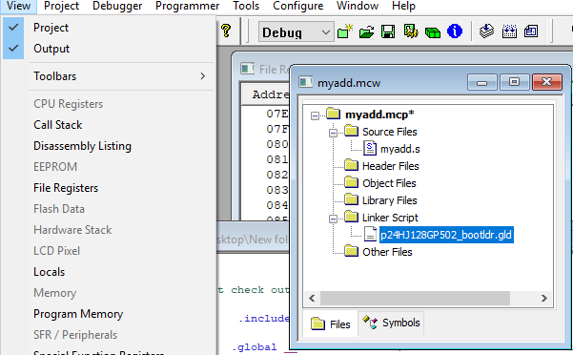

Right click on the lib file under ‘Linker Script’. Choose ‘Locate missing file’.

The lib file is under the ‘lkr’ folder of the downloaded zip file.

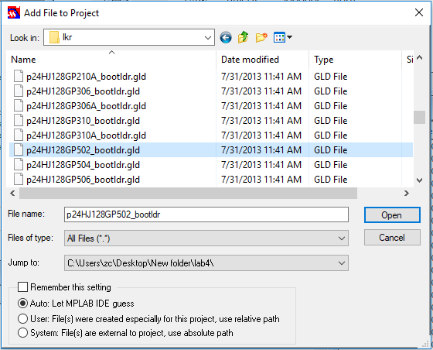

**Task 3.**

8. Values and meanings of falgs:

|  |  |  |  |  |  |  |  |  |  |  |  |  |  |  |  |  |
| --- | --- | --- | --- | --- | --- | --- | --- | --- | --- | --- | --- | --- | --- | --- | --- | --- |
|  | 15 | 14 | 13 | 12 | 11 | 10 | 9 | 8 | 7 | 6 | 5 | 4 | 3 | 2 | 1 | 0 |
|  | - | - | - | - | - | - | - | DC | IPL2 | IPL1 | IPL0 | RA | N | OV | Z | C |

|  |  |  |  |  |
| --- | --- | --- | --- | --- |
| Flag Name | N | OV | Z | C |
| Meaning | Set if the result of a mathematical operation is negative. | Overflow | Set if Result is Zero. | Set if there is a carry out of Most Significant bit |

For example,

W0 = j = 70; w1 = l =38+01=39

|  |  |  |  |  |
| --- | --- | --- | --- | --- |
|  | N | OV | Z | C |
| ADD.B w0,w1,w0->w0 = 109 | 0 | 0 | 0 | 0 |
| SUB.B w0,w1,w0 ->w0 =31 | 0 | 0 | 0 | 0 |

**Task 4.**

9. Logic operations with both 16bits and 8bits data at the same time:

In this lab, we do not consider upper 8 bits of the 16bits binary number, and keep them in the result

Example ‘AND’ operation

;u16_x & u8_y

mov u16_x, w1 ; use w1 to save x

mov.b u8_y,w2 ; use w2 to save y

and.b w1,w2,w3 ; ‘&’ operates on lower 8 bits of x and whole 8 bits of y

mov #0xFF00,w0

and w0,w1,w4 ; save first 8 bits of x to w4

mov.b w3,w4 ;combine lower 8 bits come from ‘&’ operation and first 8 bits from x

10. If you see the following warning, you probably need to go to programmer ->settings->secure segment->boot, secure, and general segments. If it still doesn’t work, go to 11.

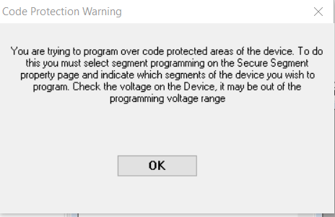

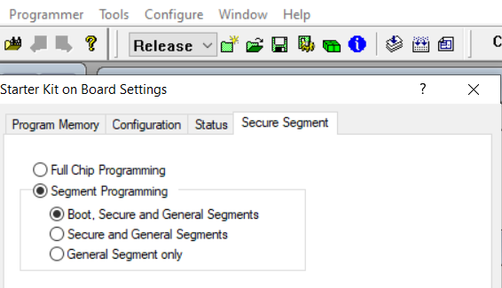

11. First, make sure that your PIC24 is pressed in very firmly into the socket.  If the pins aren't making a good connection, there are opportunities for communication and power connections to cause problems.

Next, to re-download the firmware onto your MicroStick II you need to:

1) Connect your MicroStick II while MPLAB is open (you should see notifications that its connected and detected)  
2) Go to the **Debugger -> Settings** menu  
3) Select the **Configuration** tab in the window that is opened  
4) Select the **Manual Download** button and select the *PK3FW_012890.jam* file

From there it should re-program the device, after which you can re-try downloading your programs to the PIC24.  I've attached a couple screenshots that details Steps 3 and 4 to help.  If you keep seeing this issue, please let Leo know so we can continue to explore alternative fixes.

